**Cap Images:**

1. Intent of the application is to find defects on caps

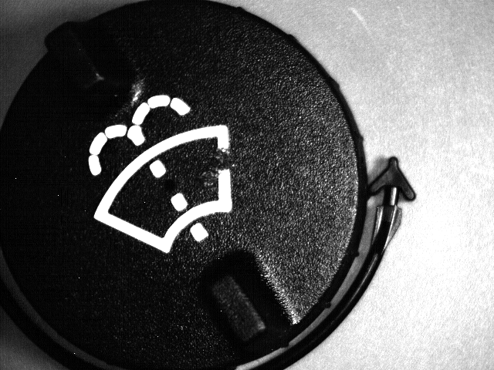

1. Use an emulator of 640x480 resolution
2. First step: Create a fixture using PatMax
3. Use TrainFlawModel to train on cap001.bmp. Remember to use the fixture created before as fixture for the train
4. Next step is to setup flex by referencing the train. Use the default recipe under flex.
5. Now use detect flaw to find the defects. Set this to find only area defects and adjust the contrast and area defect size to find the correct defects in the run time parts.